**STEPS TO DEPLOY AND USE (DONUT CHART VF) IN HELICAL INSIGHT:**

1. Extract the Folder "Donut_Chart.zip".
2. Copy "Custom_Charts" from the above zip file into the below path

....\hi\hi-repository\

1. Copy "donutChart.script" from the zip file into the below path

....\hi\hi-repository\System\Admin\CustomScripts\generic\js

1. Now Go to the HI Login page and Create a report using the Donut chart VF
2. STEPS TO CREATE A DONUT CHART VF:

* Select the required columns for donut chart VF (it takes one dimension and one measure (Ex: travel medium & travel cost))
* Click on the VF from the charts (it will direct you the file browser)
* Click on : Custom_Charts/Donut Chart.efwvf/ Donut Chart (10) and right click on it where you can see Use VF {Click on it}.
* This will generate a Donut VF chart.
* Refer to the below image where you can see a sample of Donut Chart VF.

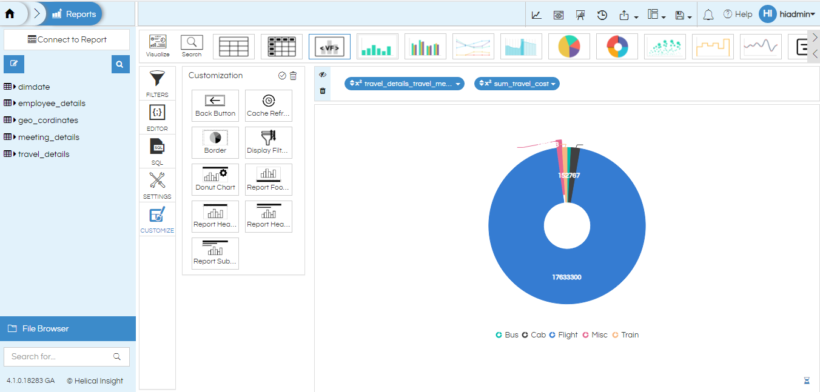

If you want to customize the VF chart accordingly, you can follow the below steps:

1. Click on the Customize. In the Customization box you will find Donut Chart Customization
2. Double click on it. Refer to the below image.

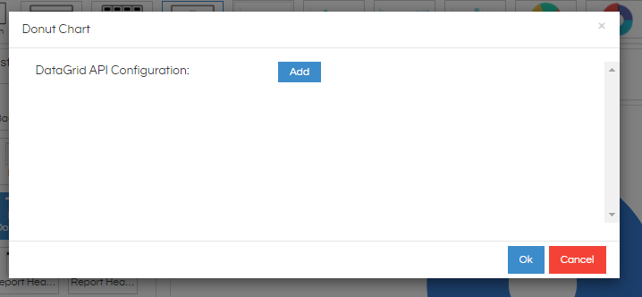

1. Click on the Add button to add your customization. It will display the type of customizations that can be applied to the VF chart(Ex: dataLabel, Legends etc).You can click on the add button multiple times to give multiple customizations. Refer to the below image.

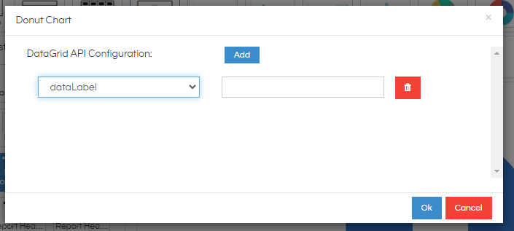

1. Once the customization is provided click on OK and apply it by clicking on tick symbol which is present in the Customization bar(Top right side).
2. By default all the properties are set as below:

* dataLabel: true,
* legends: true ,
* legends_position: Bottom,
* startAngle: 0, endAngle: 360,
* radius : 70%,
* innerRadius:30%,
* explodeIndex:3

This results in a chart as below:

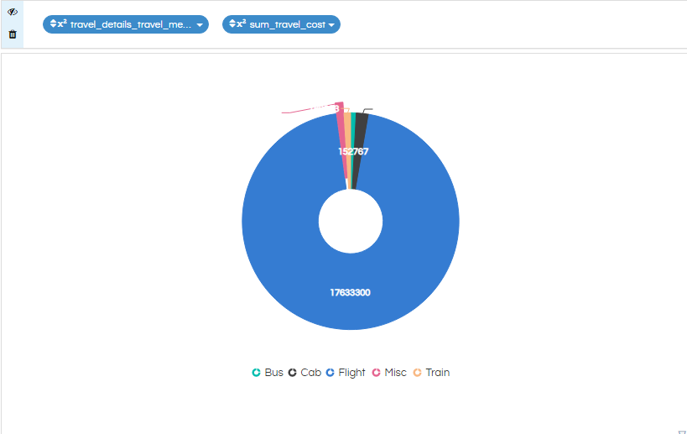

1. You can change the properties to your necessity for example refer to below image:

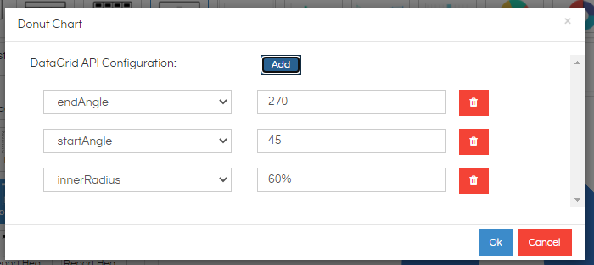

1. The above properties will result in the below VF donut chart

